Experiment 1

Aim :
Getting started with Linux basic commands for directory operations displaying directory
structure in tree format etc.

Commands :
pwd: print working directory,prints the current directory we are present in
cd : changes to the directory specified from the location of the current directory
format : cd <path>
ls : lists the files and directories contained in the current directory.
-a is used to view even hidden files
-l is used to view in long form each file In a line

mv : is used to move files format : mv <source> <destination>

mkdir : is used to make directories format : mkdir <dir_name>

rmdir : is used to remove directories
format : rmdir <dir_name>

rm : is used to remove files
format rm <filename>

clear : clear the linux command line interface

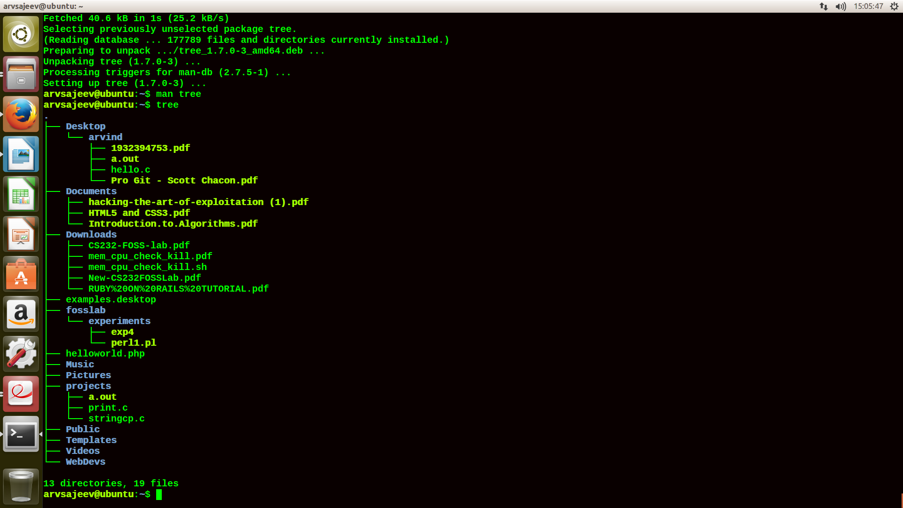
To view the file system like a tree ,the tree package is downloaded .On typing tree the content of the current directory are listed out as a tree

